Chemistry
First Page
7. Frequency of red light is 4.62 x 10¹⁴ Hz
Frequency of X-rays is 3.8 x 10¹⁹ Hz
Wavelength = C/V
C = speed of light (3.0 x 10⁸ ms), V is the frequency of the wave
Wavelength of red light = $\frac{3.0 x {10}^{8} m/s}{4.62 x {10}^{14}Hz}$
= 6.49 x 10⁻⁷ m or 649 nm
Wavelength of X-rays = $\frac{3.0 x {10}^{8} m/s}{3.8 x {10}^{19}Hz}$
= 7.89 x 10⁻¹² m or 749 x 10⁻³ nm
Red light would appear as follows because of it longer wavelength

The X-ray would appear as follows:

The distance between two successive crests or troughs is longer in the red light wave than that of the X-ray and this results from the difference in wavelength. The energy associated with a wave is directly proportional to its frequency. Hence, the shorter the wavelength the higher the frequency, and the higher the energy of the wave. Therefore, X-ray would have more energy than red light owing to its shorter wavelength and higher frequency.
8. i) Longhand electron configuration of Fe³⁺ 1s2 2s2 2p6 3s2 3p6 3d5
Orbital diagram of Fe³⁺
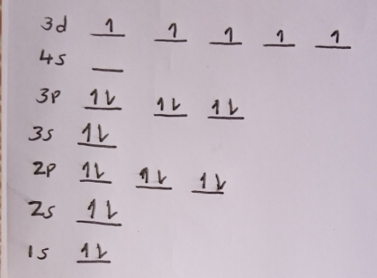
Number of unpaired electrons in Fe³⁺ is 5
ii) Longhand electron configuration of Br⁻ is 1s2 2s2 2p6 3s2 3p6 4s2 3d10 4p6
Orbital diagram of Br⁻ is as follows:
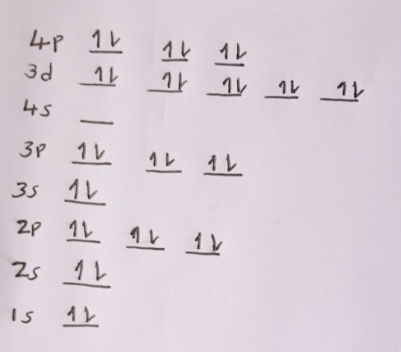
Number of unpaired electrons in Br⁻ is 0
9. Write the correct answer and EXPLAIN IN WORDS the trend that is responsible for your answer.
i) Which has a larger atomic radius, sulfur or chlorine? Explain how you know.
Sulfur has a larger atomic radius.
This is because it is the left of chlorine in the periodic table and thus has less number of protons than chlorine which decreases the nuclear attraction for the electrons in the same outer shell.
ii) Which has a smaller atomic radius, calcium or strontium? Explain how you know.
Calcium has the smaller atomic radius.
While the two elements, calcium and strontium are in the same group calcium is higher in the group than strontium and the size of atomic radius increases as you move down the group due to the increase in electron shells.
10. Write the correct answer and in your explanation, note what term refers to •'how easily an atom gives up electrons"
i) Which atom will more readily give up electrons, sodium or potassium? Explain why
Potassium will give electrons more easily than sodium because of its lower ionization energy. This is the quantity of energy that its gaseous atom in the ground electronic state must absorb to discharge an electron, resulting in a cation. The lower ionization energy in potassium is due to its lower net nuclear charge attracting its electrons.
ii) Which atom will more readily give up electrons, phosphorous or sulfur? Explain why.
Sulfur will give electrons more easily than phosphorus because it has a lower first ionization energy than phosphorus. Since the 3p electrons in sulfur (that sulfur would lose) are paired, sulfur has more electron repulsion in those orbitals than phosphorus does, so it takes less energy input to remove an electron from sulfur.
11. Explain the correct answer, making sure to include in your explanation the terms valence and core electrons.
i) Where would the largest jump in ionization energies be for oxygen? Explain why.
The largest ionization jump will occur after the sixth ionization energy following the loss of the 6th electron.
This is because the removal of the 7th electron would be the hardest at that point since you are trying to remove the 2s2 electrons from a full valence shell.
ii) Where would the largest jump in ionization energies be for magnesium? Explain why.
The largest jump would be after the second ionization energy
This is because there are 2 electrons which are relatively easy to remove (the 3s2 electrons), while the third one is much more difficult because it comes from an inner level that is closer to the nucleus and with less screening.
Second page
1. For this question, complete the Extra Help question rather than correcting your work.
Extra Help for #1
A firework produces its beautiful colors by absorbing energy, which causes the electrons of metal atoms to jump from a low energy state (also called a ground state) to a high energy state (also called an excited state). When they fall back down, they release a photon, a little packet of light. This is a form of electromagnetic radiation and if it is within the visible light region, we see color.
2. Correct your work for this question and explain your correction in WORDS.
i) What is the frequency (In Hz) and energy (in MJ) of red light that has a wavelength of 630 nm?
Frequency = C/ λ
C is the speed of light in vacuum (3.0 x 10⁸ ms)
Wavelength should be in m (1 nm = 1 x10⁻⁹ m)
Wavelength in meters = 6.3 x 10⁻⁷ m
Frequency = $\frac{3.0 x {10}^{8}}{6.3 x {10}^{-7}m}$ = 4.76 x 10¹⁴ Hz
Frequency = 4.76 x 10¹⁴ Hz
Energy of wave = hv
H is the Planck’s constant (6.626 x 10⁻³⁴ J/sec)
V= frequency of the wave
Energy = 6.626 x 10⁻³⁴ J/sec x 4.76 x 10¹⁴ Hz
= 3.15 x 10⁻¹⁹ J
1 MJ = 1 x 10⁶ J
Therefore, (3.15 x 10⁻¹⁹ J) / (1 x 10⁶ J)
= 3.15 x 10⁻²⁵ MJ
ii) What is the frequency (in Hz) and wavelength (in nm) of orange light that has an energy 2.18 x 10⁻²⁵ MJ?
Frequency = energy/h
h is the Planck’s constant (6.626 x 10⁻³⁴ J/sec)
First convert energy from MJ to J
1 MJ = 1 x 10⁶ J
(2.18 x 10⁻²⁵) x (1 x 10⁶ J)
= 2.18 x 10⁻¹⁹ J
= $\frac{2.18 x {10}^{-19} J}{6.626 x {10}^{-34} J/sec}$ = 3.29 x 10¹⁴ Hz
Frequency = 3.29 x 10¹⁴ Hz
Wavelength = C/ V
C is speed of light in vacuum (3.0 x 10⁸ ms) and v is frequency of the wave
Wavelength = $\frac{3.0 x {10}^{8}m/s}{3.29 x {10}^{14} sec}$ = 9.12 x 10⁻⁷ m
1m = 1 x 10⁹ nm
Therefore, to convert the wavelength to nm, we multiply it by 1 x 10⁹ nm
= (9.12 x 10⁻⁷ m) x (1 x 10⁹)
= 912 nm
Wavelength = 912 nm
3. Write the correct answer with a complete explanation in WORDS.
Extra Help for #1
i) Write the shorthand electron configuration of zirconium.
[Kr] 4d² 5s²
ii) Write the shorthand electron configuration of rubidium.
[Kr] 5s¹
4. Write the correct answer and FXPLAIN IN WORDS how you determined the correct number of valence electrons.
Extra Help for #4
i) How many valence electrons does zirconium have?
2, because its 3d orbital has 2 electrons, but it should accommodate 10 meaning it is unfilled.
ii) How many valence electrons does rubidium have?
1, because the only unfilled orbital is 5s with one electron.
5. Write the correct answer and EXPIAIN IN WORDS how you determined the charge that the atom assumes when it becomes an ion.
Extra Help for #5:
i) What charge does rubidium assume when it becomes an ion?
It becomes Rb⁺ and therefore has a charge of +1 because it less the one electron in its unfilled 5s orbital.
ii) What charge does oxygen assume when it becomes an ion?
It becomes O²⁻ and therefore has a charge of -2 because it gains 2 electrons to fill its unfilled 2p orbital.
6. Correct your work for this question and explain your correction in WORDS.
Extra Help for #6:
i) If the wavelength of electromagnetic radiation is 5.6 x 10⁻⁹ m, what is the frequency in Hz?
Frequency = C / λ
Λ is wavelength and C is the speed of light in a vacuum (3.0 x 10⁸ m/s)
Frequency = $\frac{3.0 x {10}^{8}m/s}{5.6 x {10}^{-9}}$ = 5.36 x 10¹⁶ Hz
Frequency = 5.36 x 10¹⁶ Hz
ii) If the energy of electromagnetic radiation is 1.44 x 10⁻²⁰ J, what is the frequency in Hz?
Energy = hv
Where h is the Planck’s constant (6.626 x 10⁻³⁴ J/sec) and v is the frequency of the wave
v = energy/ h
= $\frac{1.44 x {10}^{-20}}{6.626 x 10^-34}$ = 2. 17 x 10¹³ Hz
Frequency = 2. 17 x 10¹³ Hz
Third Page
1. On a subatomic level, explain what happens to allow these beautiful colors to form when we set off fireworks.
As the fireworks get heated, their electrons get excited and release photons of light of different wavelengths. These different wavelengths are seen as waves of different colors.
2a. The energy released by barium in a firework is 3.6 x 10⁻²² kJ. What is the frequency of this electromagnetic radiation in Hz?
Frequency = Energy/ h
h is the Planck’s constant (6.626 x 10⁻³⁴ J/sec)
Frequency = $\frac{3.6 x {10}^{-22}}{6.626 x 10^-34}$ = 5.43 x 10¹¹ Hz
Frequency = 5.43 x 10¹¹ Hz
b. What is the wavelength of this electromagnetic radiation in nm?
λ = C / v
λ is the wavelength, c is the speed of light (3.0 x 10⁸), and v is the frequency
λ = $\frac{3.0 x {10}^{8}}{5.43 x 10^11}$ = 5.52 x 10⁻⁴ m
1 m = 1 x10⁹ nm
Therefore, when the wavelength is converted, the result is:
= (5.52 x 10⁻⁴ m) x (1 x10⁹)
= 5.52 x 10⁵ nm
3. Write the shorthand electron configuration of barium.
[Xe] 6s2
4. How many valence electrons does barium have?
Barium has 2 valence electrons
5. Barium that is used in fireworks is actually an ion, often Ba(NO₃)2. What charge does barium assume when it becomes an ion?
Barium exist in the compound as Ba²⁺ and therefore has a charge of +2.
6. Rubidium releases 7.8 x 10⁻⁷ m of electromagnetic radiation to produce the distinctive green color we see in fireworks. What is the frequency of this electromagnetic radiation in Hz?
v = C / λ
λ is the wavelength, c is the speed of light (3.0 x 10⁸), and v is the frequency.
V = $\frac{3.0 x {10}^{8}}{7.8 x {10}^{-7}}$ = 3.85 x 10¹⁴ Hz
Frequency = 3.85 x 10¹⁴ Hz
7. Using the frequency values you calculated for barium (#2a) and rubidium (#6), draw two sample waves that correctly compare their relative wavelengths. Then in words explain which metal ion would release electromagnetic radiation with a greater energy and how you know this. Hint: You should be the terms inversely or directly related in your explanation.
Frequency of barium = 5.43 x 10¹¹ Hz and its wavelength is 5.52 x 10⁵ nm
Its sample wave would appear as follows:

Frequency of Rubidium = 3.85 x 10¹⁴ Hz and its wavelength is 7.8 x 10² nm
Its sample wave would appear as follows:

Rubidium would release an electromagnetic radiation with higher energy than barium because of the higher frequency of the waves. The frequency of an electromagnetic wave is directly proportional to its energy.
8. Write the longhand electron configuration for Rb⁺.
1s2 2s2 2p6 3s2 3p6 4s2 3d10 4p6.
b. Draw the orbital diagram of Rb⁺.
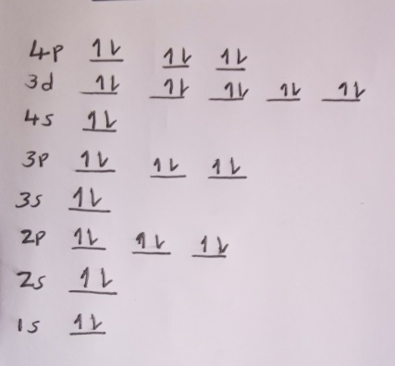
c. How many unpaired electrons does Rb⁺ have?
Rb⁺ has zero unpaired electrons because all its orbitals have been filled to become stable in the process of becoming an ion.
9. Which has a larger atomic radius, Ba or Rb? Explain how you know. Hint: Remember, vertical position affects size more than horizontal position.
Ba has a larger atomic radius than Rb.
This is because it has an extra electron shell.
10. Which atom, barium or rubidium, will more readily give up electrons? Explain how you know.
Barium would give electrons more readily because the extra electron shell increases the shielding effect on the electrons in the outer shell hence can be lost easily.
11. Looking at the successive ionization energies below, I can confirm that the element I am testing is rubidium and not barium. Explain how this data helps me to do that, making sure to include the terms valence and core electrons in your explanation.
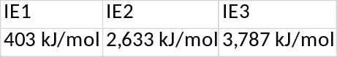
This data shows that the largest ionization energy jump is when losing the second electron. This is consistent with Rubidium because losing the second electron would mean dislodging it from an already filled and stable orbital. If it was barium the largest ionization energy jump would be when losing the third electron.

